**Nearpod lesson:**

<https://np1.nearpod.com/sharePresentation.php?code=176808afa7d9917892ed53a1babbf9df-1&oc=lesson-library&utm_source=link>

**Central Message Videos:**

[**https://youtu.be/5VmvNZAqAak**](https://youtu.be/5VmvNZAqAak)

[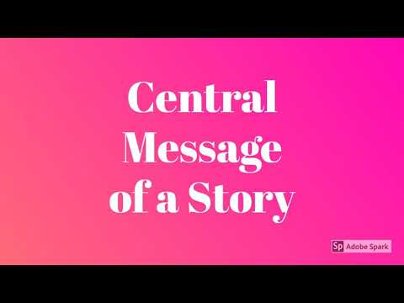](https://youtu.be/5VmvNZAqAak)

[**https://youtu.be/wGjCt9II4kM**](https://youtu.be/wGjCt9II4kM)

[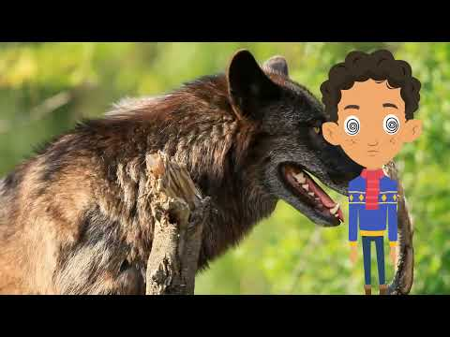](https://youtu.be/wGjCt9II4kM)